LIFT EQUATION
As altitude increases, the lift generated by an aircraft decreases. This is primarily because air density decreases with altitude, meaning there are fewer air molecules to interact with the aircraft's wings to produce lift.

DRAG EQUATION
Factors Affecting Lift
- Angle of Attack (AOA)
  - Lift increases with AOA up to a critical angle, beyond which stall occurs.
- Airfoil Shape
  - Cambered airfoils generate more lift at lower AOA.
- Air Density (ρ)
  - Lift decreases with altitude as air density drops.
- Velocity (V²)
  - Lift increases with the square of airspeed.
- Wing Area (S)
  - Larger wing area increases lift.
- Surface Condition
  - Rough or dirty wings reduce lift due to disrupted airflow.
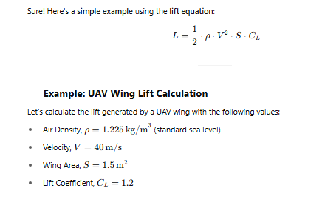
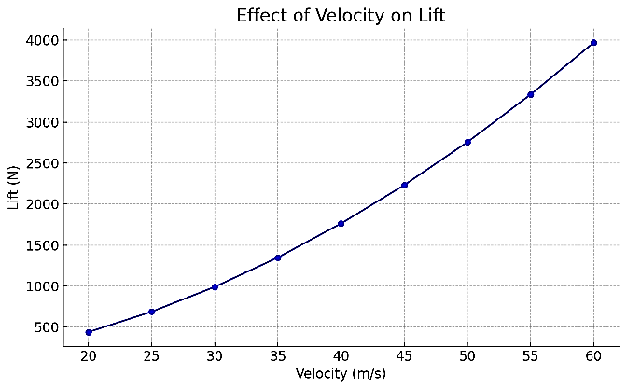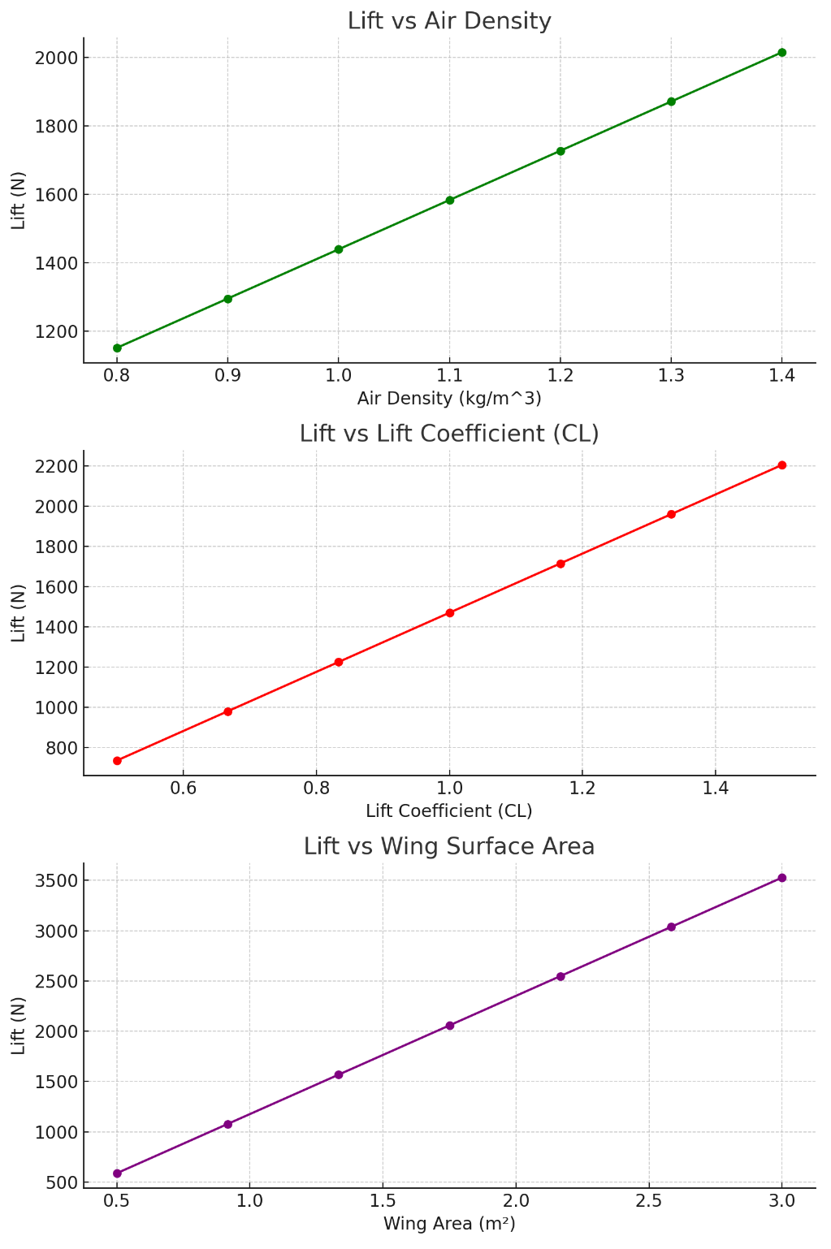

Factors Affecting Drag
- Air Density (ρ)
  - Drag increases with higher density (e.g., at lower altitudes).
- Velocity (v²)
  - Drag increases with square of speed.
- Frontal Area / Shape
  - Blunt shapes cause more form drag; streamlined bodies reduce it.
- Surface Roughness
  - Rough surfaces increase skin friction drag.
- Angle of Attack
  - Higher AOA increases both lift and induced drag.
- Wing Configuration
  - High aspect ratio wings reduce induced drag.
- Reynolds Number
  - Affects boundary layer behavior and drag characteristics.
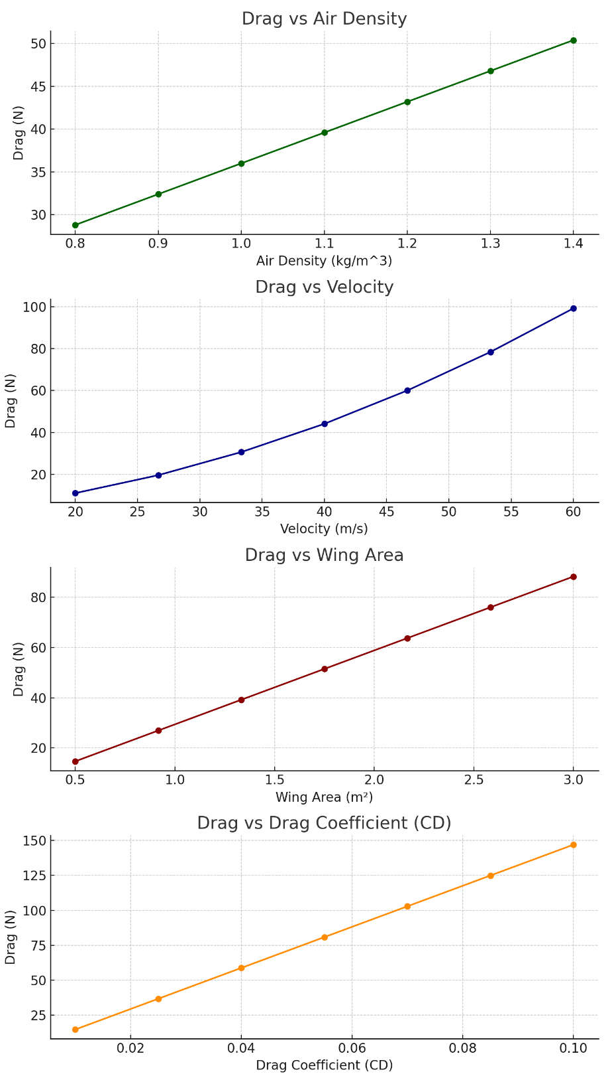
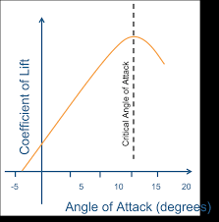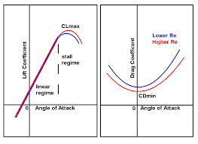

Laminar flow and turbulent flow describe the movement patterns of fluids. Laminar flow is characterized by smooth, orderly layers of fluid sliding over one another without mixing, ideal for scenarios where minimal resistance is desired. Turbulent flow features chaotic, swirling patterns with irregular fluctuations, often causing increased energy dissipation and mixing.
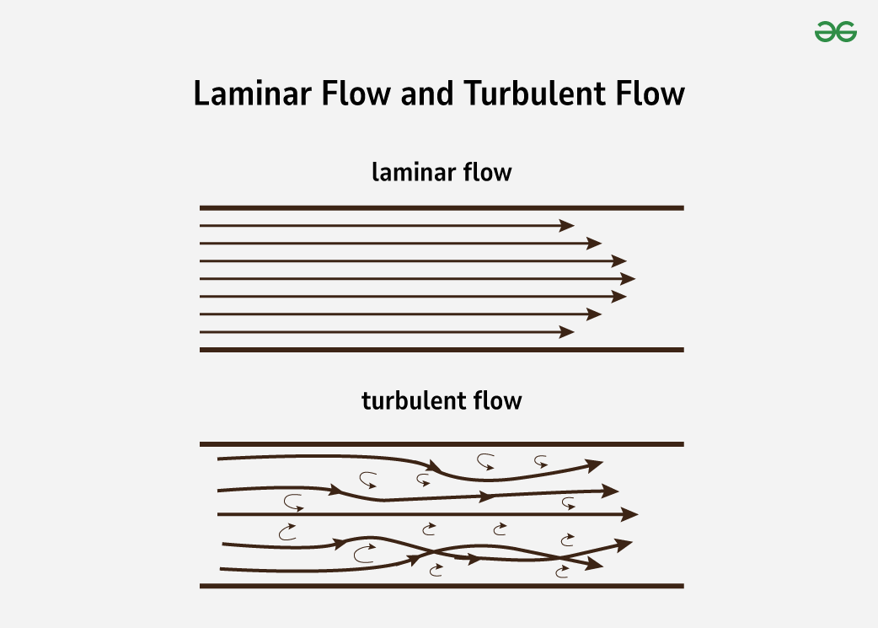

Laminar Flow Definition
Laminar flow is a type of fluid movement where the fluid moves smoothly in parallel layers, without any mixing between them.
Each layer of fluid slides past the adjacent layers with minimal friction and disruption. This results in a very orderly flow where all the particles of the fluid move in straight, predictable paths.
- In laminar flow, the motion of the fluid particles is very predictable, as they move in straight, parallel lines.
- Laminar flow typically occurs at lower velocities and in fluids with higher viscosity.
- It is more likely to occur in pipes and channels that have smooth internal surfaces.
- The condition for laminar flow can be characterized by the Reynolds number, which is a dimensionless number in fluid mechanics. Laminar flow generally occurs when the Reynolds number is less than 2000.

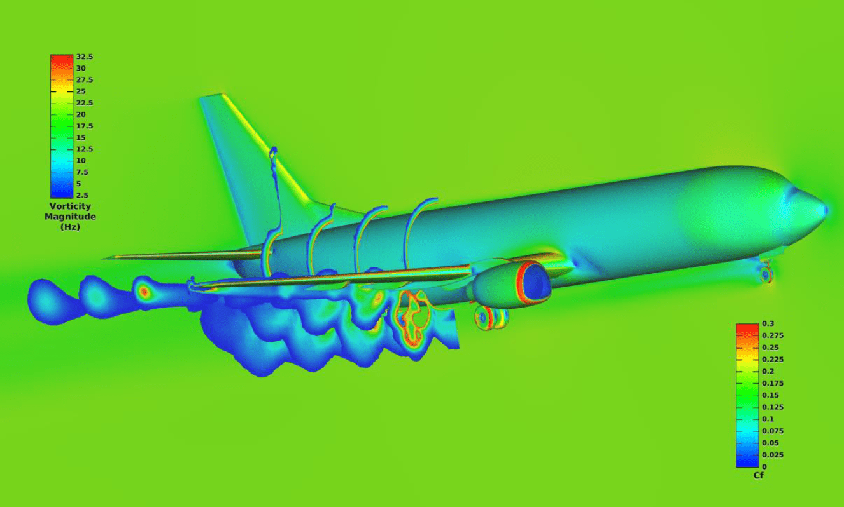

Turbulent Flow Definition
Turbulent flow is a type of fluid movement characterized by chaotic changes in pressure and velocity within the fluid. Turbulent flow includes irregular fluctuations and swirling vortices. This randomness causes mixing of the fluid layers, leading to increased energy dissipation and resistance to flow.
- Turbulent flow typically occurs at higher velocities, where fluid motion becomes chaotic and unpredictable.
- Irregular Fluid Motion: In turbulent flow, the fluid experiences rapid variations in speed and direction, which results in swirling and eddies.
- Increased Mixing: Due to the chaotic nature of turbulent flow, there is significant mixing of the fluid, which can be beneficial for processes that require rapid blending of substances.
- Energy Dissipation: Turbulent flow leads to higher energy loss through friction and resistance compared to laminar flow, affecting efficiency in fluid transport systems.
- Reynolds Number: Turbulent flow generally happens when the Reynolds number exceeds 4000, a dimensionless number indicating flow conditions in fluid dynamics.
- Common in Nature: Turbulent flow is commonly observed in natural settings, such as in river rapids, smoke from a fire, and atmospheric storms.

Difference between Laminar and Turbulent Flow
The following table shows the difference between laminar and turbulent flow
Aspect | Laminar Flow | Turbulent Flow
Flow Description | Smooth and orderly flow | Chaotic and irregular
Layers | Flows in parallel layers without mixing | Layers mix due to eddies and fluctuations
Fluid Resistance | Low resistance due to smooth flow | High resistance due to mixing and fluctuations
Velocity | Velocity is consistent and predictable | Velocity varies significantly
Application Example | Used in microfluidics and laminar air flow hoods | Found in fast-flowing rivers and HVAC systems
Pressure Drop | Low Pressure Drop | High Pressure Drop
Mixing Efficiency | Low mixing efficiency | High mixing efficiency
Flow Stability | Stable flow | Unstable flow sensitive to disturbances

How to Avoid Turbulent Flow?
To avoid turbulent flow, follow these key strategies:
- Reduce Flow Speed: Decreasing the velocity of the fluid flow helps maintain a laminar state.
- Smooth Surface: Ensure that the internal surfaces of pipes and channels are smooth to reduce disturbances.
- Decrease Fluid Density: Using fluids with lower densities can help reduce the onset of turbulence.
- Increase Fluid Viscosity: More viscous fluids tend to flow more smoothly, which can help prevent turbulence.
- Choose Smaller Pipes: Smaller diameters in pipes encourage laminar flow by limiting the space in which turbulence can develop.
- Control Flow Rate: Regulating the flow rate to stay within a range that supports laminar flow is crucial.

Reynolds Number
The Reynolds number is a dimensionless quantity in fluid mechanics that helps predict the flow regime—whether laminar or turbulent—within a particular fluid flow situation. It is calculated using the formula:
Re = (ρ⋅v⋅L)/ μ
where:
- ρ is the fluid density,
- v is the flow velocity,
- L is a characteristic linear dimension (like pipe diameter),
- μ is the dynamic viscosity of the fluid.
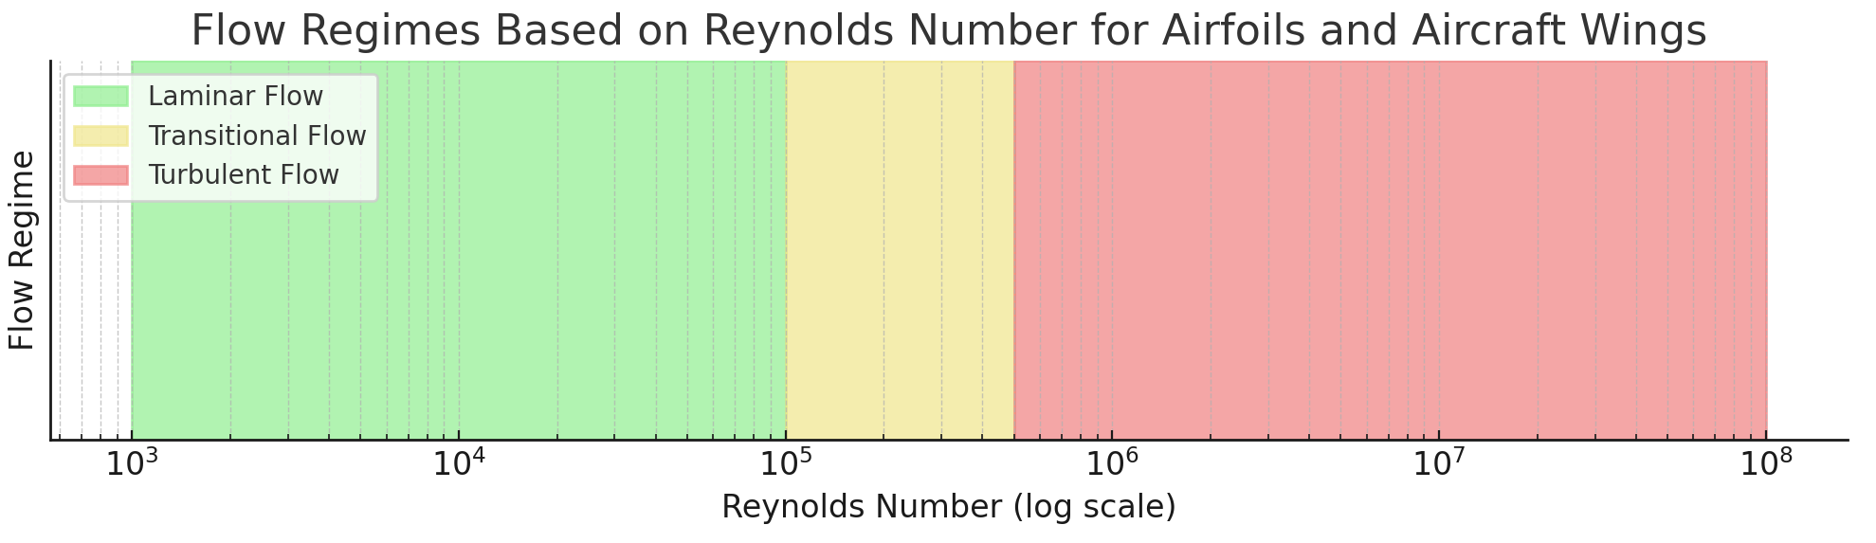

For flow in pipes:
- Laminar flow typically occurs when the Reynolds number is less than 2000. In this regime, the flow is smooth and orderly.
- Transitional flow occurs between Reynolds numbers of about 2000 and 4000, where the flow shifts from laminar to turbulent.
- Turbulent flow is generally observed when the Reynolds number exceeds 4000, characterized by chaotic fluid motion with eddies and vortices.
- The Reynolds number provides a key criterion for determining the nature of the flow, facilitating the design and analysis of systems involving fluid movement.
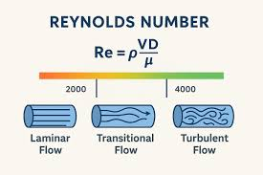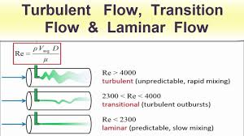

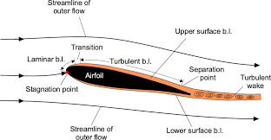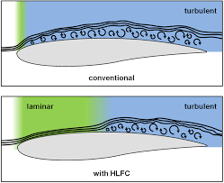

Reynolds number us mach number

Both the Reynolds number (Re) and the Mach number (M) are important dimensionless quantities used in fluid dynamics to characterize fluid flow, particularly in aerodynamics. However, they represent different aspects of fluid behavior and are important under different circumstances.

Reynolds number (Re)
- The Reynolds number compares inertial forces to viscous forces within a fluid.
𝑅𝑒=𝜌𝑣𝐿/𝜇
- Significance: It helps predict if flow will be laminar or turbulent.
- Relevance: Important for low-speed flows where viscosity is dominant, like in pipe flow or boundary layer behavior.
Mach number (M)
- The Mach number is the ratio of an object's speed to the speed of sound in the fluid.
𝑀=𝑣/𝑎
. 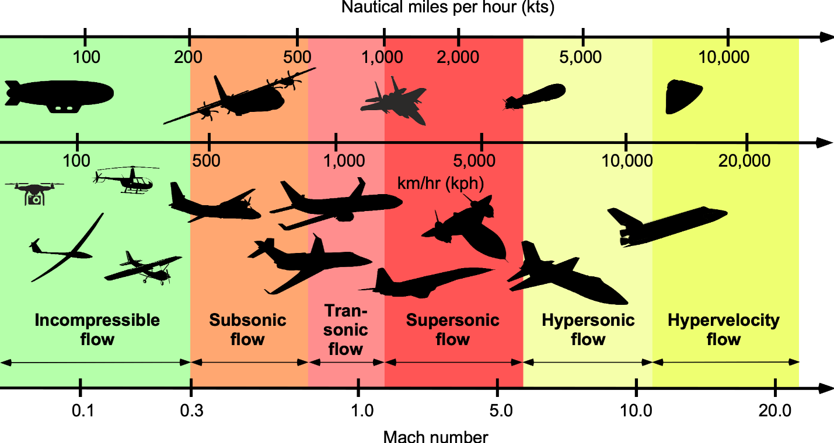
- Significance: It indicates the impact of compressibility effects.
- Relevance: Crucial for high-speed flows, classifying flows as subsonic, transonic, supersonic, or hypersonic.

Range of Reynolds and Mach numbers encountered by various flight articles.
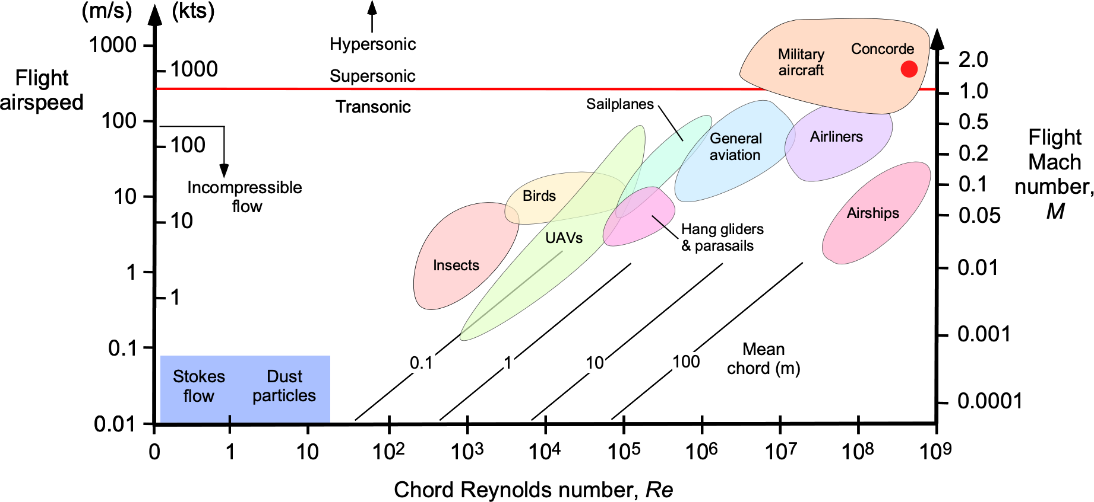
Lift-to-drag ratio increases with Reynolds number and drops significantly at lower values.
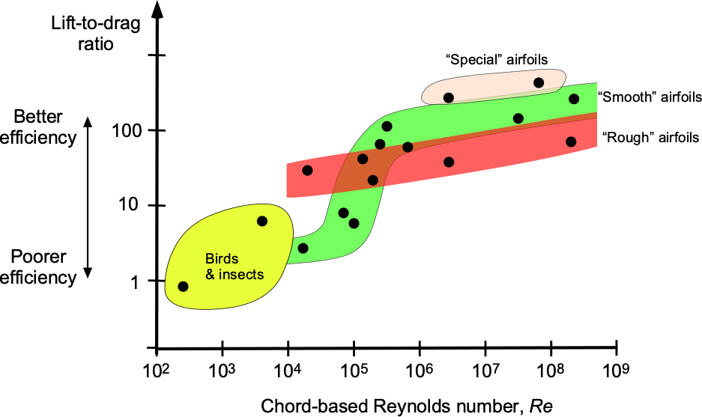
1. Low Reynolds number for small aircraft (e.g., MAVs)
- Small Unmanned Aerial Vehicles (UAVs) and Micro Air Vehicles (MAVs) operate at low airspeeds and have smaller wing dimensions, resulting in low Reynolds numbers, typically ranging from 10⁴ to 10⁵.

- Challenges at Low Re:
  - Reduced Aerodynamic Performance: Airfoils designed for high Reynolds numbers (like those on large aircraft) exhibit significantly reduced lift and increased drag at low Reynolds numbers.
  - Boundary Layer Behavior: Laminar boundary layers are more prone to separation at low Reynolds numbers, leading to increased pressure drag and poor lift generation.
- Design Considerations:
  - Airfoil Selection: Specialized airfoils, like thin cambered plates or flat plates, can outperform traditional airfoils at low Reynolds numbers by delaying flow separation.
  - Winglets: Winglets, particularly wingtip fences, can improve aerodynamic performance and delay stall at low Reynolds numbers.
  - Flow Control: Technologies like Gurney flaps can be used to enhance lift and reduce drag at low Reynolds numbers, although the effect may vary depending on the specific application.
2. High Reynolds numbers for large aircraft
- Large transport aircraft cruise at higher airspeeds and possess larger wings, resulting in high Reynolds numbers, ranging from millions to tens of millions.
- Impact at High Re:
  - Thinner Boundary Layers: Higher Reynolds numbers result in thinner boundary layers, leading to reduced skin friction drag.
  - Improved Lift and Pitching Moment: The lift coefficient increases and the pitching moment becomes more nose-down as the Reynolds number increases,
- Design Considerations:
  - Aerodynamic Optimization: Wing designs are optimized to maintain attached flow over a wider range of flight conditions, particularly in the presence of shock waves.
  - Supercritical Airfoils: These airfoils are designed to delay drag divergence and improve performance in the transonic regime.
3. High Mach numbers for high-speed aircraft
- Aircraft flying at high subsonic, transonic, and supersonic speeds (approaching Mach 1 or beyond), require considerations of compressibility effects.
- Challenges at High Mach number:
  - Shock Wave Formation: As local airflow approaches Mach 1, shock waves form on the wing, leading to increased drag (wave drag), reduced lift, and potential control issues.
  - Boundary Layer Separation: Shock waves can induce boundary layer separation, leading to buffet and reduced wing efficiency.
- Design Considerations:
  - Wing Sweep: Wing sweep helps reduce the effective Mach number experienced by the wing, delaying the onset of shock waves and reducing wave drag.
  - Supercritical Airfoils: Designed with flatter upper surfaces and a blunter leading edge, these airfoils redistribute the shock waves further aft on the wing, minimizing drag.
  - Area Rule: This aerodynamic design principle aims to minimize wave drag by smoothing out the cross-sectional area distribution of the aircraft along its length.

